# Mini Project 2

## Development

**React.js Code**

Below is my React code from my React Front-End folder:

BatmanOrigin.jsx (components/BatmanOrigin.jsx)

BatmanPowers.jsx (components/BatmanPowers.jsx)

BatmanProfile.jsx (components/BatmanProfile.jsx)

CharactersMainContent.jsx (components/CharactersMainContent.jsx)

Footer.jsx (components/Footer.jsx)

GamesCarousel.jsx (components/GamesCarousel.jsx)

GamesMainContent.jsx (components/GamesMainContent.jsx)

HeaderNavBar.jsx (components/HeaderNavBar.jsx)

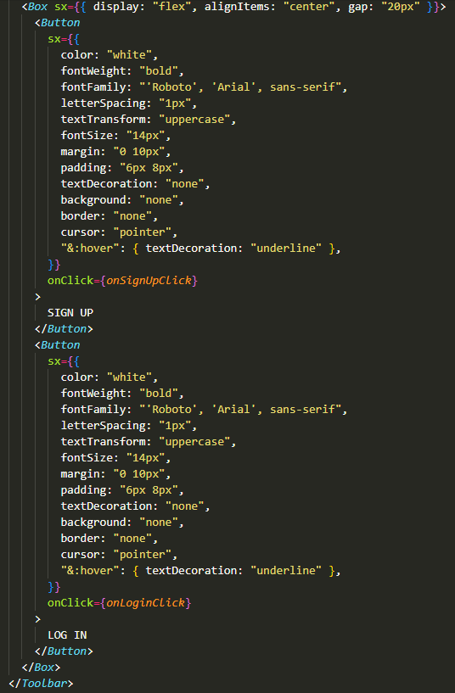

HomeCarousel.jsx (components/HomeCarousel.jsx)

LoginDialog.jsx (components/LoginDialog.jsx)

PopUpModal.jsx (components/PopUpModal.jsx)

SignUpDialog.jsx (components/SignUpDialog.jsx)

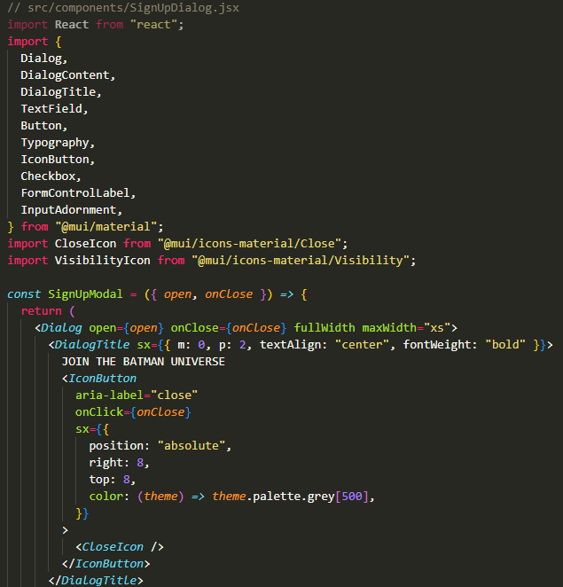

CharactersPage.jsx (pages/CharactersPage.jsx)

GamesPage.jsx (pages/GamesPage.jsx)

App.jsx (src/App.jsx)

main.jsx (src/main.jsx)

**Express API**

Below is my code from my Express API Back-End folder:

authController.js (controllers/authController.js)

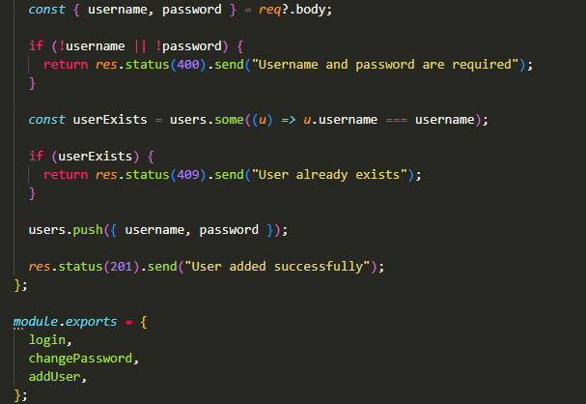

charactersController.js (controllers/charactersController.js)

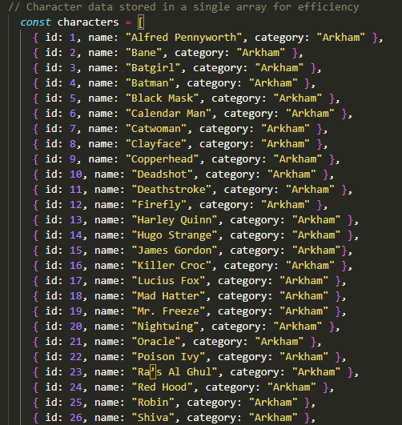

gamesController.js (controllers/gamesController.js)

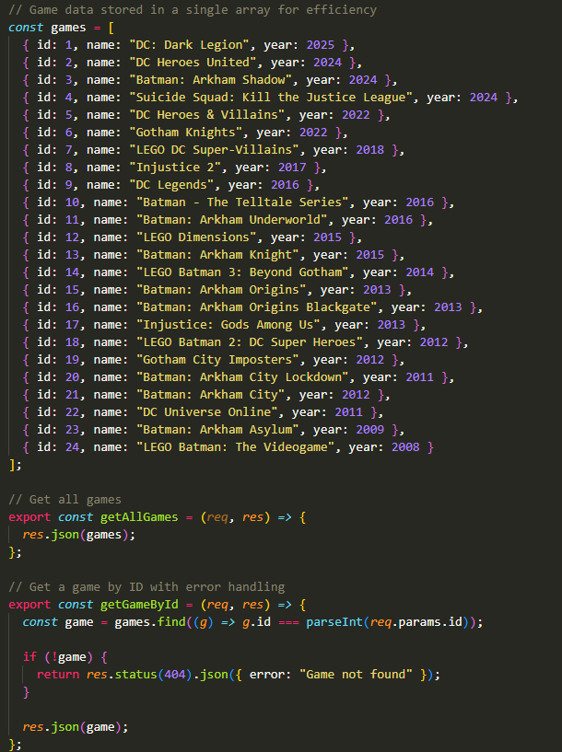

authRoutes.js (routes/authRoutes.js)

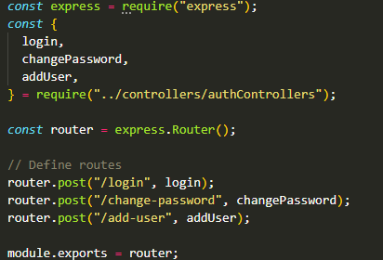

characters.js (routes/characters.js)

games.js (routes/games.js)

index.js (routes/index.js)

app.js (src/app.js)

swagger.json (src/swagger.json)

index.js (src/index.js)

## Testing

**Express API**

Below are my tests (including Jest Test Snapshot) from my Express API Back-End folder:

Jest Test Snapshot

localhost:3000 (http://localhost:3000/)

localhost:3000/api-docs (http://localhost:3000/api-docs)

Get all games (localhost:3000/api-docs/#/get_games)

Get a game by ID (localhost:3000/api-docs/#/get_games__id_)

Get all characters (http://localhost:3000/api-docs/#/default/get_characters)

Get all character by ID (http://localhost:3000/api-docs/#/default/get_characters)

localhost:3000/api/characters (<http://localhost:3000/api/characters>)

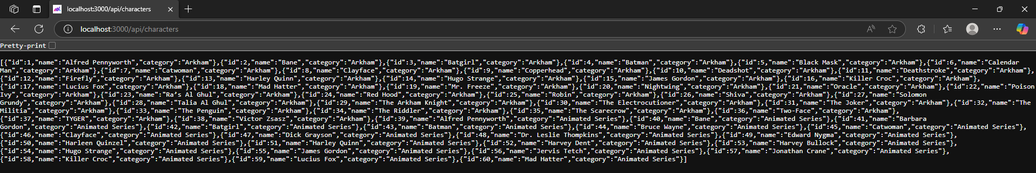

localhost:3000/api/games (<https://localhost:3000/api/games>)

